AUTOCONSO

User Guide

### **AUTOCONSO app presentation**

AutoConso is an easy-to-use, easy-to-use iOS app that lets you track all the maintenance, repair, and fuel costs associated with the vehicles in your home.

By adding your vehicle and filling in the details at the pump, AutoConso will create a dashboard showing how many kilometers you have traveled, fuel costs since the purchase, and the average fuel consumption of your vehicle. , the cost per km and the daily cost.

So you can compare the cost of using your vehicle with the taking of any other means of transportation.

Here is an example of dashboard for cost management (Fig.1)



### **How Can I use the app ?**

1. User Agreement Acceptance

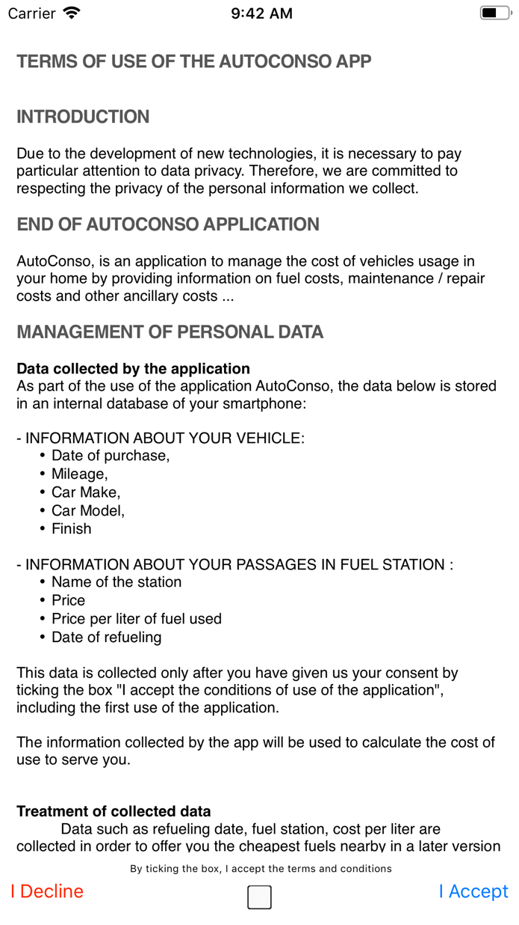

Fig. 1 : User Agreement Screen

* Read carefully and entirely the terms and conditions that display at the app launching, just after the splash screen.
* Tick the tickbox to show your acceptance, and then tap on I Accept

🡺 This stores your agreement on the app’s internal database

NB : You can decline your agreement when you want accessing on the “More” Menu > Terms and conditions 🡺 This erases all data stored on the internal database

1. Vehicle Management
   1. Add a new vehicle

Once the user agreement granted, the app displays an empty statistics screen because there is no vehicle added yet.

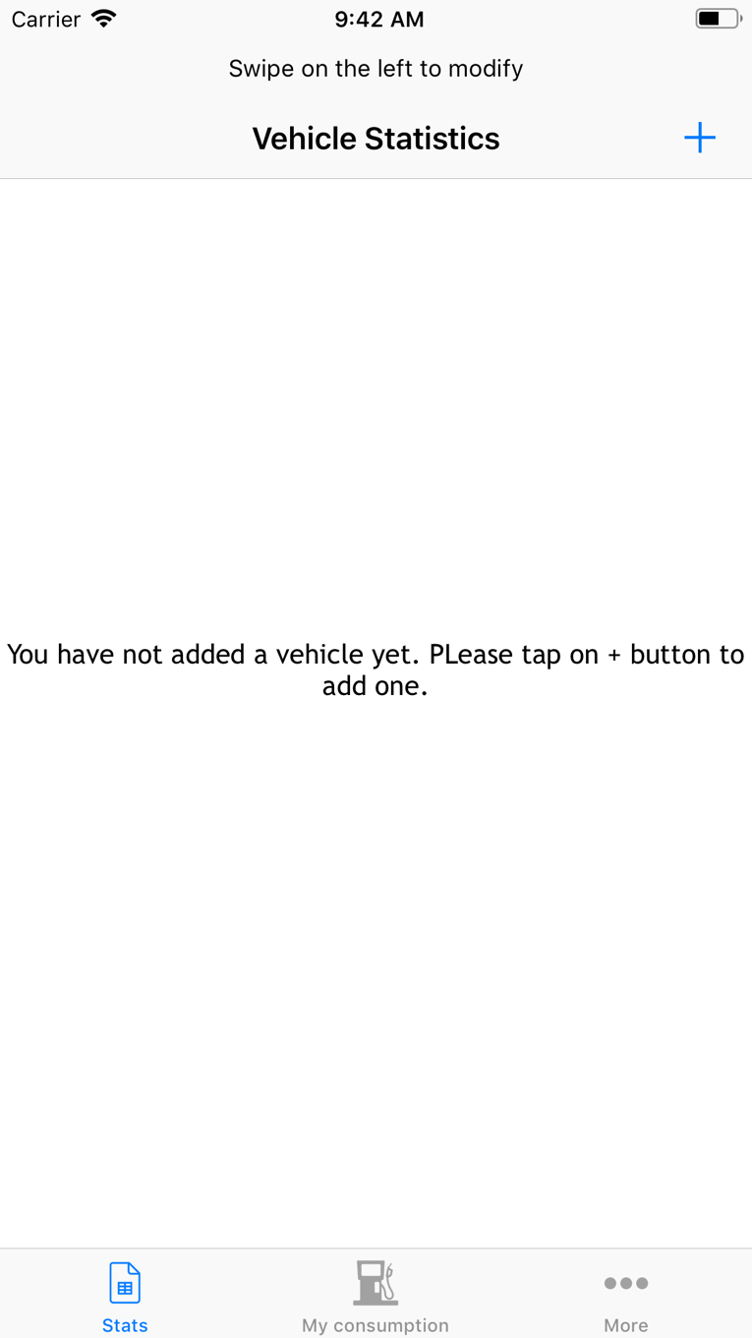

Fig. 2 : Vehicle Statistics screen

* Tap on the + button to add a vehicle

The Screen Fig.3 allows you to add your vehicle. You can choose between Bike, Scooter or Car.

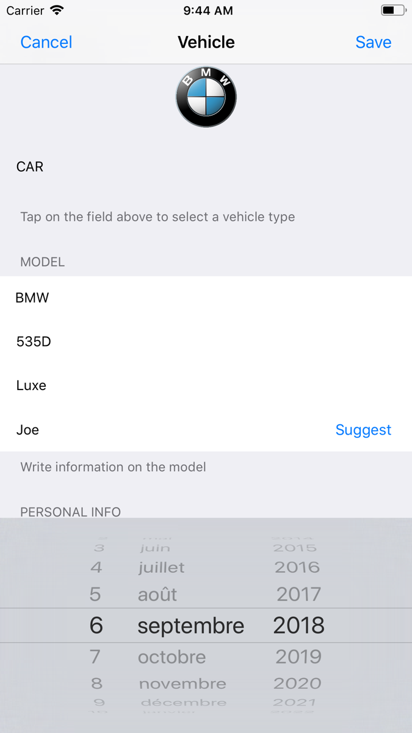

Fig. 3 : Vehicle Form Screen

* Select a vehicle Type on the pickerview

🡺 To respect Apple developer guidelines, many functionalities use pickerviews to ease user entry

* If a car is selected, you’ll have a pickerview with car brands. For other vehicles the entry is free, with no control for Make, Model and Refurbishing
* You can give a nickname for your vehicle. If you want, you can tap on suggest button to let the app suggest a nickname to your vehicle randomly
* You can also set car registration date, buying date to allow the app calculating the data to populate the vehicle dashboard.
* You can also if you want fill up the serial number, license plate number and personal notes.
* Tap on Save
* The screen fig.4 is displayed with no Data
  1. View details and modify a vehicle

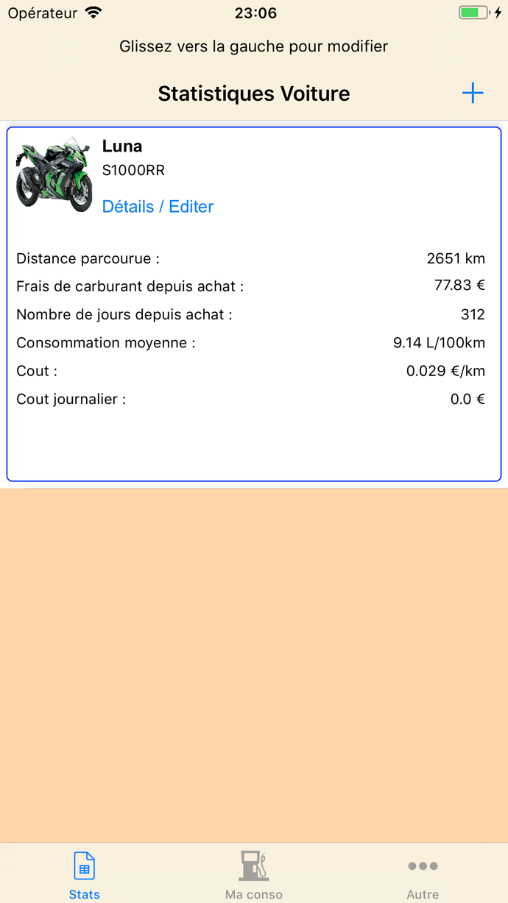

Fig. 4 : Vehicle Statistics Screen

You can easily view details of a vehicle from Fig.4

* Just tap on View/Edit

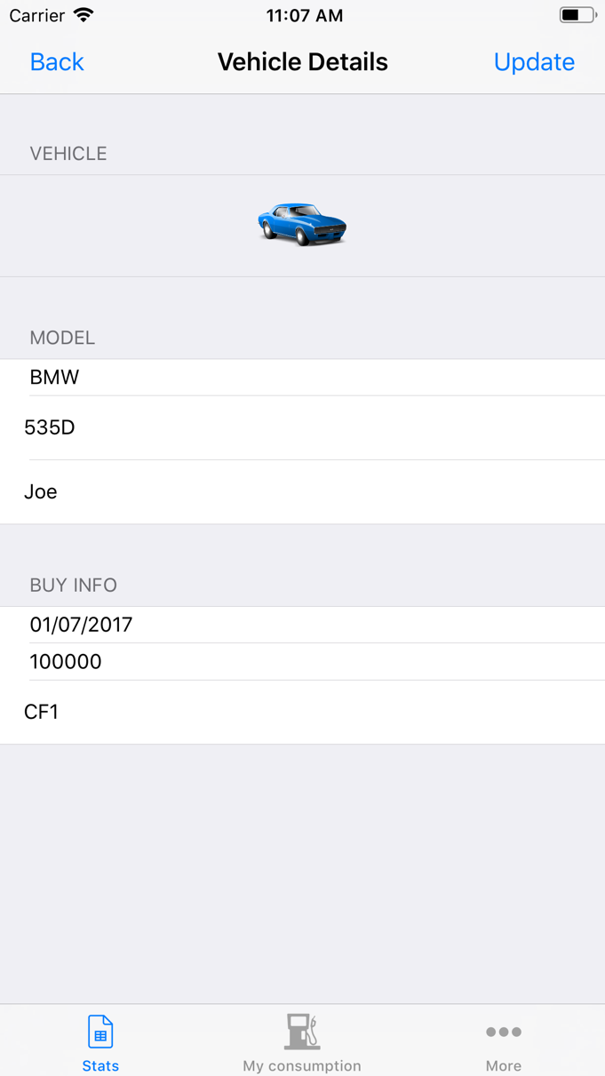

Fig. 5 : Vehicle Edit Screen

* From Fig. 5, you can view some details, and then easily edit any information
* To update these informations, just tap on Update

🡺 Your vehicle information are updated

* 1. Delete a vehicle

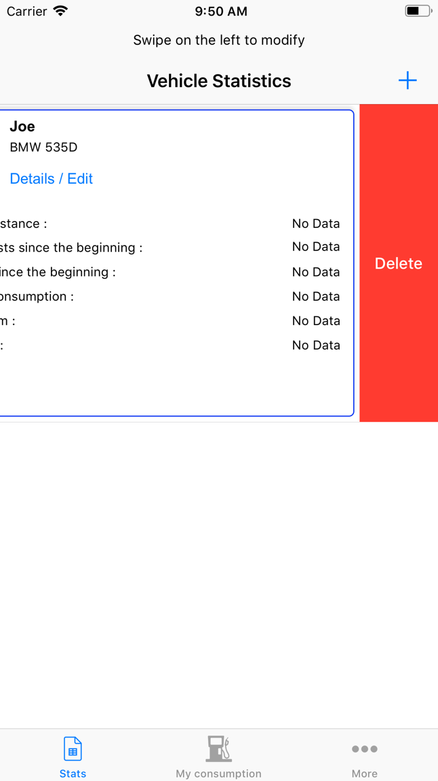

Fig. 6 : Delete a vehicle

* From Fig. 4, just swipe the vehicle row on the left and tap on the delete button.
* A popup asks to confirm the deletion of the vehicle as well as all the associated data. If you answer “Yes” all will be deleted.

1. Manage vehicle fueling costs
   1. Add a fueling

* Tap on My Consumption on the Navigation Bar

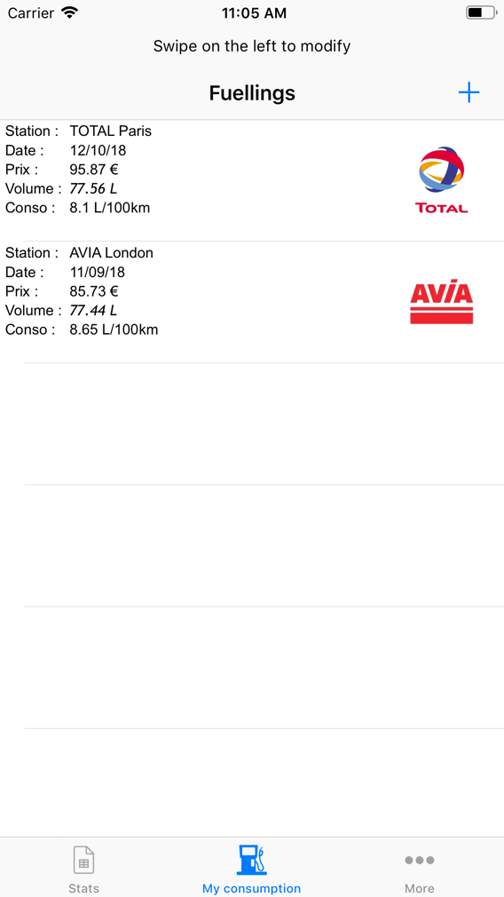

Fig. 7 : Fuelling management screen

* Tap on + Button to add a fueling row

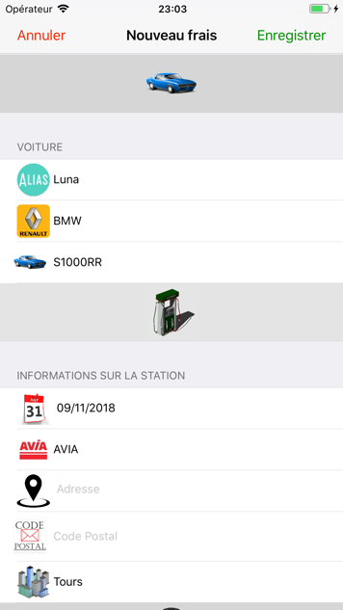

* Fill in the fueling information add tap on save to save your fueling

🡺 The row will be added on the Screen Fig. 7

* 1. Edit a fueling item
* Form Fig. 7, just swipe the row you want to edit on the left
* Tap on the grey button edit

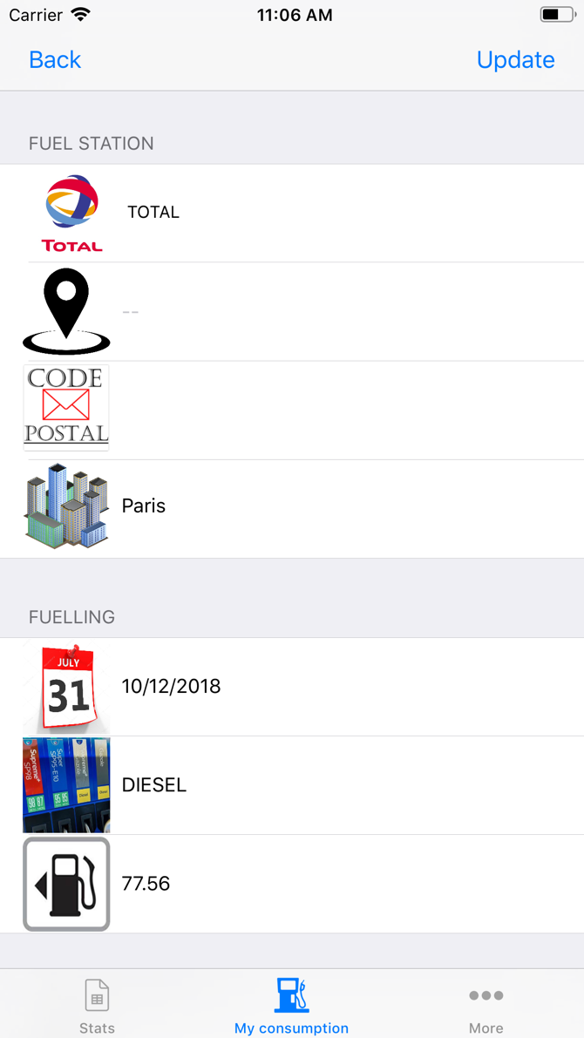

* Verify / View the associated information, edit any field you want to modify and tap on update to update the row

🡺 The row will be updated

* 1. Deleting a fueling row
* Form Fig. 7, just swipe the row you want to delete on the left, tap on deleted button and confirm.

🡺 The selected row will be deleted

1. More Menu
   1. App and Developer Information

As suggested on the Apple Devloper Guidelines, the developer information is easily accessible to answer questions as well as app version and date.

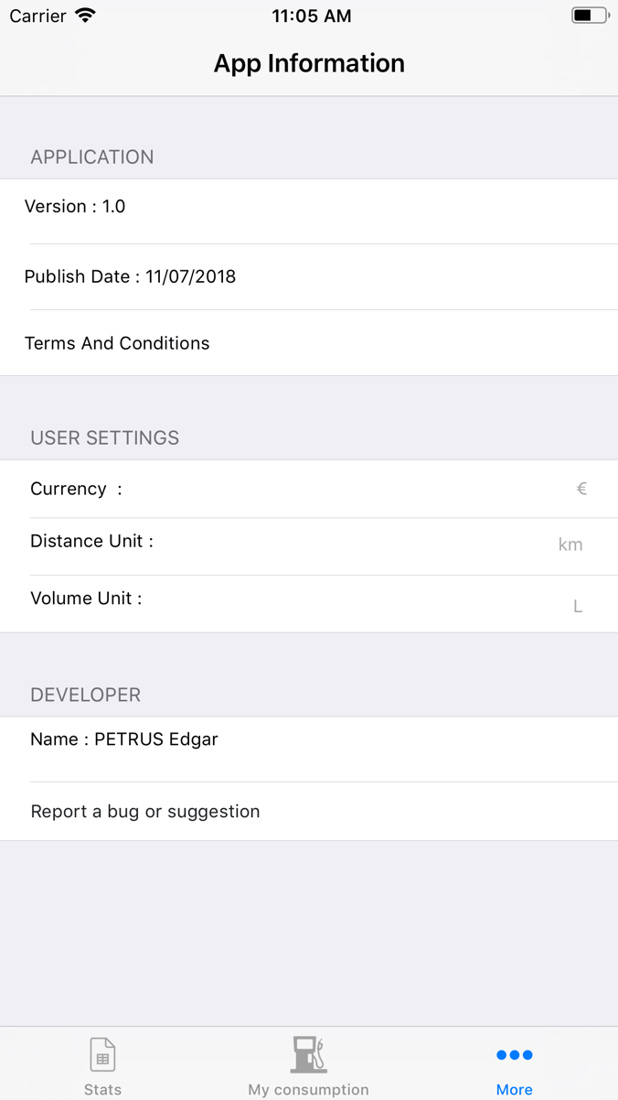

* To report a bug or send suggestions, the user can tap on Report a bug button, an email can be sent by opening a mail item. The app cannot send mails itself, the user have to check the mail information and then he can send mail by himself.
  1. Terms and Conditions
* The terms and conditions can be accessible on the More Menu.
* The user can decline the terms and conditions if he want. As he decline the personal data storage, the app data will be erased.
  1. User Settings
* The user can set easily the units he wants to see on the app : Currency, distance and volume units
* Tap on the unit you want to modify, a popup will be displayed, fill in the information and validate